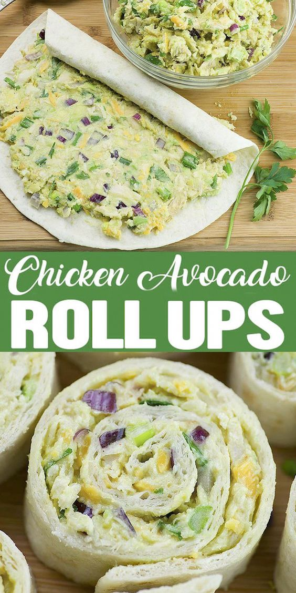
Kip avocado wraps
Ingrediënten
Vlees
• 2 cups Chicken
Groenten
• 1 Avocado, ripe
• 1 1/2 tbsp Cilantro or parsley, fresh
• 1/2 tsp Garlic powder
• 2 Green onion
• 2 tbsp Red onion
Specerijen
• 1 1/2 tbsp Lime juice
Bakken en specerijen
• 1 Black pepper, Freshly ground
• 1/4 tsp Salt
Brood en gebak
• 5 Tortillas
Zuivel
• 1/2 cup Cheddar cheese
• 2 tbsp Greek yogurt, plain
Stappen
NOTES: I had enough filling for 5 tortillas (10 inch diameter). You can use 6 (8 inch) tortillas.
In a large bowl combine all ingredients for Chicken Avocado salad. Stir until evenly blended.
Spread the mixture over tortilla and roll up tightly. Repeat with remaining salad.
Slice with serrated knife into ½ inch slices. You can slice them immediately or refrigerate until firm (about 30 mins). It’s easier to slice when chilled.

